**MULTI-TARGET IMAGE RECOGNITION WITH AUGMENTED REALITY FOR A SMART IN-STORE SHOPPING EXPERIENCE**

**A PROJECT REPORT**

***Submitted by***

**S. SUBRAMANIAN [Reg No: RA1711003010059]**

**S. GUPTA [Reg No: RA1711003010567]**

***Under the Guidance of***

**Dr. B. AMUTHA**

**(Head of Department, Department of Computer Science and Engineering)**

**In Partial Fulfillment of the Requirements**

**for the Degree of**

**BACHELOR OF TECHNOLOGY**



**DEPARTMENT OF COMPUTER SCIENCE AND ENGINEERING**

**FACULTY OF ENGINEERING AND TECHNOLOGY**

**SRM INSTITUTE OF SCIENCE AND**

**TECHNOLOGY**

**KATTANKULATHUR- 603 203**

**MAY 2021**



SRM INSTITUTE OF SCIENCE AND TECHNOLOGY

KATTANKULATHUR – 603 203

BONAFIDE CERTIFICATE

Certified that this B.Tech project report titled “**MULTI-TARGET IMAGE RECONIGITION WITH AUGMENTED REALITY FOR A SMART IN-STORE SHOPPING EXPERIENCE”** is the bonafide work of **Ms. S. SUBRAMANIAN and Ms. S. GUPTA** who carried out the project work undermy supervision. Certified further, that to the best of my knowledge the work reported herein does not form part of any other thesis or dissertation on the basis of which a degree or award was conferred on an earlier occasion for this or any other candidate.

Dr. B. AMUTHA

**SUPERVISOR**

Head of Department

Department of Computer Science and

Engineering

Dr. B. AMUTHA

**HEAD OF THE DEPARTMENT**

Department of Computer Science and

Engineering

Signature of the Internal Examiner

Signature of the External Examiner

**Own Work Declaration**

Department of Computer Science and Engineering

**SRM Institute of Science & Technology**

**Own Work* Declaration Form**

This sheet must be filled in (each box ticked to show that the condition has been met). It must be signed and dated along with your student registration number and included with all assignments you submit – work will not be marked unless this is done.

To be completed by the student for all assessments

**Degree/ Course :** B.TECH. / COMPUTER SCIENCE AND ENGINEERING

**Student Name :** SHWETHA SUBRAMANIAN ; SHUBHI GUPTA

**Registration Number :** RA1711003010059 ; RA1711003010567

**Title of Work :** MULTI-TARGET IMAGE RECONIGITION WITH AUGMENTED REALITY FOR A SMART IN-STORE SHOPPING EXPERIENCE

I / We hereby certify that this assessment compiles with the University’s Rules and Regulations relating to Academic misconduct and plagiarism**, as listed in the University Website, Regulations, and the Education Committee guidelines.

I / We confirm that all the work contained in this assessment is my / our own except where indicated, and that I / We have met the following conditions:

* Clearly references / listed all sources as appropriate
* Referenced and put in inverted commas all quoted text (from books, web, etc)
* Given the sources of all pictures, data etc. that are not my own
* Not made any use of the report(s) or essay(s) of any other student(s) either past or present
* Acknowledged in appropriate places any help that I have received from others (e.g. fellow students, technicians, statisticians, external sources)
* Compiled with any other plagiarism criteria specified in the Course handbook / University website

I understand that any false claim for this work will be penalised in accordance with the University policies and regulations.

|  |
| --- |
| **DECLARATION:** |
| I am aware of and understand the University’s policy on Academic misconduct and plagiarism and I certify that this assessment is my / our own work, except where indicated by referring, and that I have followed the good academic practices noted above. |
| If you are working in a group, please write your registration numbers and sign with the date for every student in your group. |

**RA1711003010059**

**28-05-2021**

**RA1711003010567**

**28-05-2021**

ACKNOWLEDGEMENT

We express our humble gratitude to **C. Muthamizhchelvan**, Vice Chancellor (I/C), SRM Institute of Science and Technology, for the facilities extended for the project work and his continued support.

We extend our sincere thanks to **Dr. Revathi Venkataraman**, Professor & Chairperson, School of Computing, SRM Institute of Science and Technology, for her invaluable support

We wish to thank **Dr. B. Amutha**, Professor & Head, Department of Computer Science and Engineering, SRM Institute of Science and Technology, for her invaluable support, suggestions and encouragement throughout the period of the project work.

We are extremely grateful to our Academic Advisor **Dr. P. Vishalakshi,** Assistant Professor, Department of Computer Science and Engineering, SRM Institute of Science and Technology, for their great support at all the stages of project work.

We register our immeasurable thanks to our Faculty Advisors**, Dr. A. Vijay Vasanth,** Assistant Professor**,** Department of Computer Science and Engineering, SRM Institute of Science and Technology, and **M. Arul Prakash,** Assistant Professor**,** Department of Computer Science and Engineering, SRM Institute of Science and Technology, for leading and helping us to complete our course.

Our inexpressible respect and thanks to our guide, **Dr. B. Amutha,** Professor & Head, Department of Computer Science and Engineering, SRM Institute of Science and Technology, for providing us an opportunity to pursue our project under her mentorship. She provided us the freedom and support to explore the research topics of our interest. Her passion for solving the real problems and making a difference in the world has always been inspiring.

We sincerely thank staff and students of the Computer Science and Engineering Department, SRM Institute of Science and Technology, for their help during our research. Finally, we would like to thank our parents, our family members and our friends for their unconditional love, constant support and encouragement.

SHWETHA SUBRAMANIAN

SHUBHI GUPTA

**ABSTRACT**

This project aims to present a design to streamline the retail industry and enhance the in-store shopping experience. With the help of feature tracking, product packaging can be tracked as multi-image targets. Customers can scan a product from a hand-held device and obtain salient features specific to the product that will assist the customer in their decisions. This involves product attributes presented with a visual aid such as 3D models, regarding the brand, reviews, dietary information, prices, discounts, alternatives, etc. The complete application will be deployed on an android device, focusing to support an inventory for the store. With the help of cloud technology, the application can be improved to maintain dynamic metadata for the products which would allow to make up for constant packaging modifications, price changes and for the data to be available in multiple different languages.

**TABLE OF CONTENTS**

|  |  |  |
| --- | --- | --- |
| CHAPTER NO. | TITLE | PAGE NO. |
|  | ABSTRACT | v |
|  | LIST OF FIGURES | viii |
| 1. | INTRODUCTION | 1 |
| 1.1 | GENERAL | 1 |
| 1.2 | PURPOSE | 2 |
| 2. | LITERATURE REVIEW | 4 |
| 2.1 | BASE PAPERS | 6 |
| 2.2 | SURVEY FROM RESEARCH | 9 |
| 2.3 | INFERENCE FROM SURVEY | 17 |
| 3. | METHODOLOGY | 19 |
| 3.1 | EXISTING AND PROPOSED SYSTEM | 19 |
| 3.2 | SYSTEM ARCHITECUTRE | 22 |
| 3.3 | HARDWARE AND SOFTWARE REQUIREMENTS | 24 |
| 3.4 | FEATURE TRACKING WITH AUGMENTED REALITY | 25 |
| 3.5 | 3D MODEL AND UI ELEMENTS | 27 |
| 3.6 | MAINTAINING DATABASES AND SETTING UP CLOUD | 28 |
| 4. | OBSERVATIONS AND RESULTS | 29 |
| 5. | CONCLUSIONS | 31 |
| 6. | REFERENCES | 32 |
| 7. | APPENDIX | 35 |
| 7.1 | MARKET STUDY | 35 |
| 7.2 | CODE | 38 |
| 8. | PLAGIARISM REPORT | 53 |
| 9. | PAPER PUBLICATION PROOF | 54 |

**LIST OF FIGURES**

|  |  |  |
| --- | --- | --- |
| FIGURE NO. | CAPTION | PAGE NO. |
| 2.1 | Futuristic use of AR/VR market | 6 |
| 2.2 | Product classification accuracy per number of training instances per product | 8 |
| 2.3 | Product recognition accuracy | 8 |
| 2.4 | Application areas of Web AR | 9 |
| 2.5 | User interacting with Shoppingu system | 10 |
| 2.6 | Conceptual model of the role of MAR apps in smart retailing | 12 |
| 2.7 | Represential of artificial markers in an AR application | 13 |
| 2.8 | ShelfTorchlight in use | 14 |
| 2.9 | Central aspects of experimental consumption from the retailers' point of view | 15 |
| 2.10 | Camera rotation and orientation record | 16 |
| 3.1 | An overview of the existing shopping system | 20 |
| 3.2 | An overview of the proposed shopping system | 21 |
| 3.3 | The UML use-case diagram of the system architecture. | 22 |
| 3.4 | The UML sequence diagram of the system architecture | 23 |
| 3.5 | The UML object diagram of the system architecture. | 23 |
| 3.6 | Diagrammatic representation of the hardware and software requirements for the architecture | 25 |
| 3.7 | Output of the feature recognition performed on the different faces of the product packaging image | 26 |
| 3.8 | Rendered image of the 3D model of a teacup | 27 |
| 4.1 | Output images of the running application. | 30 |
| A 1.1 | Survey Results | 37 |

**LIST OF SYMBOLS, ABBREVIATIONS**

|  |  |  |
| --- | --- | --- |
| AR |  | AUGMENTED REALITY |
| CV |  | COMPUTER VISION |
| VR |  | VIRTUAL REALITY |
| CNN |  | CONVOLUTION NEURAL NETWORKS |
| OS |  | OPERATING SYSTEM |
| API |  | APPLICATION PROGRAMMING INTERFACE |
| UI |  | USER INTERFACE |

**CHAPTER 1**

**INTRODUCTION**

* 1. **GENERAL**

Recent trends in the retail industry have demonstrated that online shopping has often proved to be more satisfactory for customers than in-store shopping [1]. The root cause of this is the restrictions that brands encounter due to limited packaging space and industry regulations. In the data-driven world, customers search for more directed information before making their decision, such as reviews, dietary details, alternatives, and discounts. This project aims to provide a solution to remodeling the in-store shopping experience by allowing brands to serve analogous information using Augmented Reality capabilities. By utilizing feature tracking with image recognition to register products as multiple image targets, customers can scan products from handheld devices to obtain product-specific information in a visually pleasing manner. The employment of cloud technology supports the maintenance of dynamic product metadata, which can be efficiently modified to the branding needs and accessed remotely. This also allows for data to fetched in multiple languages which benefits travelling customers to get assimilated with foreign products. Besides streamlining the process and improving product analysis and brand engagement, this design also poses a smart solution to pandemic regulations by allowing customers to be self-sufficient in their shopping process. Computer Vision has fantastic capacity for AR applications. Since feature tracking depends on graphic attributes that are innately current to register the camera, it does not require planning the environment and is not restricted to a small amount, like magnetic, mechanical, or ultrasonic sensors are. Robustness of camera registration is not the only characteristic of AR where object recognition techniques can contribute. Managing occlusions between the real objects and the virtual ones can also be accomplished.

* 1. **PURPOSE**

Products in the present day are laden with tightly packed text on the packaging. Not only can this be extremely difficult to read often the details are industry mandatory and does not help the user understand whether they should buy the product. Consider the following scenario where the user is interested in knowing whether the food product, they are planning to buy works with the Keto Diet or not. Often the product packaging will enlist the details on the ingredients present in the product and the customer would have to spend time in analysing this for themselves.

In such a case it would benefit the user more if such dietary information were easily visible on the packaging itself. In another scenario, the user is rarely ever presented with alternative options to the product he is trying to buy immediately next to the product on the shelf, such as different flavours of the same product or different products which might suit the customer better in terms of cost.

For such similar reasons, the design proposed is to achieve the following:

* How to increase the assimilation of product details for users when viewing products(they are not familiar with them)?
* How to improve the general user experience in retail?
* How to negate language barriers and build assurance for foreign brands and travelling customers?
* How to make shopping a more comfortable experience for reticent and aged customers?
* How to make in-store shopping more self-sufficient in pandemic-related situations?

# CHAPTER 2

**LITERATURE REVIEW**

There has been a major resurgence in the application of AR in retail and commerce as it improves user experience [2]. Some previous works have targeted clothing [3,4], library systems [5,6], product assembly [7], and construction lines [8]. The majority of these have been executed on mobile applications [9] to improve feasibility and handiness and reduce hardware costs. Recognition and Classification has always been at the forefront of improving and automating existing systems by allowing them to make the make the visual decision. Majority of these have been based on Support Vector Machines [10] and Deep Neural Networks [11]. The main goal of artificial intelligence has consistently been to benefit the everyday life by upgrading existing software systems with decision making capabilities. Augmented Reality is one such application of Artificial Intelligence which has benefited user interaction and satisfaction with the targeted product. [12] discusses the growing relationship between product, multimedia, and graphic design professions, and the industrial revolution. There is also a major focus on how this has affected the labour market. Product, Multimedia, and Graphic Design are crucial in the retail industry; therefore, these careers were largely influenced by the rise in information technologies such as AR and VR. These changes have caused an urgent need for design practitioners to familiarize themselves with the upcoming innovative capabilities.

The existing methods in identification of packaged products are brought to light in [13]. The current common standards involve bar-coding, which requires dynamic user input and is restricted to single product at a time. Computer vision (CV) has previously permitted numerous applications to perform the same process more efficiently with large informational output. To evaluate the capability of recent CNN architectures to dependably distinguish packaged goods in a retail environment, the researchers experimented with an open-source data set. Results from the research highlighted that for a 90% accuracy six images were more than enough for training the model, but for a 95% IC accuracy, over thirty more images would also have to be added to the training set. Thus, the study concluded that image-based product identification proves to be a far more efficient approach than bar-coding.

Since mobile devices are now common present with almost every individual, they have become an important element in the development of applications that can aid the everyday life. [14] talks about a similar example of aiding the blind in navigation with the help of mobile-based application. [15] introduces a handheld based AR structure for displaying merchandise data to a customer. The arrangement permits the consumer to look at a 3D prototype of the insides of the packaged product. The contents can be viewed virtually over the package without physically opening and dealing with the contents. Additional digital data can also be provided, such as product videos, web-based content, and product data from a peripheral database. The system establishes context cognizance by adjusting the presented content conferring to the position of the operator; diverse content can be revealed in a store and at home.

* 1. **BASE PAPERS**

Paper [12] discusses the growing relationship between product, multimedia, and graphic design professions, and the industrial revolution. There is also a major focus on how this has affected the labour market. Product, Multimedia, and Graphic Design are crucial in the retail industry; therefore, these careers were largely influenced by the rise in information technologies such as AR and VR. These changes have caused an urgent need for design practitioners to familiarize themselves with the upcoming innovative capabilities.

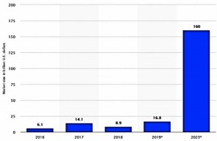

Figure 2.1 Futuristic use of AR / VR market

Applications of Virtual – Augmented Reality in Marketing:

* Furniture shopping has been virtualized to allow users to view the new furniture at home before beginning prompted to buy it. Some leading brands following this approach are Houzz, Housecraft, ARule which can virtually measure different pieces of furniture to aid the buys better in choosing the best.
* Another application in the Furniture industry is that of catalogues which show the assembly of dismantled products. IKEA is the leading brand in this case. It also allows the user to view the furniture I the desired location over a handheld device.
* Books and media have been some of the target fields. This involves transforming the standard materials such as paper, hardcovers, etc. into dynamic interactive stories utilizing the camera on a handheld device.
* Advertising has been employing 3D dynamics where products such as food, toys, drinks, clothing, etc. can be manually handled and viewed by the user over a virtual setting
* Additionally, there has also been a growth in the concept of virtual fitting rooms which allows a user to try on clothing without the actual physical piece.

Paper [13] brings light to the current methods in the identification of packages products. The current common standards involve barcoding, which requires dynamic user input and is restricted to single product at a time. Computer vision (CV) has previously permitted numerous applications to perform the same process more efficiently with large informational output. To evaluate the capability of recent CNN architectures to dependably distinguish packaged goods in a retail environment, the researchers experimented with an open-source dataset.

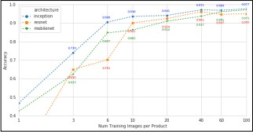

Figure 2.2 Product classification accuracy per number of training instances per product

Results from the research highlighted that for a 90% accuracy six images were more than enough for training the model, but for a 95% IC accuracy, over thirty more images would also have to be added to the training set. Thus, the study concluded that image-based product identification proves to be a far more efficient approach than barcoding

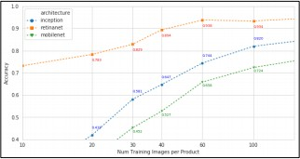

Figure 2.3 Product recognition accuracy

Paper [15] introduces a handheld based AR structure for displaying merchandise data to a customer. The arrangement permits the consumer to look at a 3D prototype of the insides of the packaged product. The contents can be viewed virtually over the package without physically opening and dealing with the contents. Additional digital data can also be provided, such as product videos, web-based content, and product data from a peripheral database. The system establishes context cognizance by adjusting the presented content conferring to the position of the operator; diverse content can be revealed in a store and at home.

* 1. **SURVEY FROM RESEARCH**

Paper [16] gives an overview of Mobile AR technology, its current existing implementations, and the challenges faced by such a system. It also explains the various Web AR approaches for adaptive and scalable solutions. Key Points:

* Mobile AR Principles
* Basic implementation mechanisms
* Challenges of combining AR with Web platforms.
* Improving existing technologies to adapt to Web A

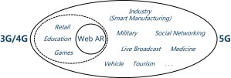

Figure 2.4 Application areas of Web AR

In-store basic shopping events are frequently accompanied by searches for product-associated data. MRShoppingu [17] is an interactive experience that uses a mixture of context recognition, customer behaviors, and AR with real-time content. Consumers can interact with goods substantially and spontaneously and are supplied with related subjects and suggestions. This may help customers in the buying activity by boosting productivity and confidence of obtaining and facilitating an increased individualized and enjoyable spending activity.

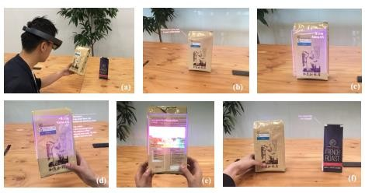

Figure 2.5 User interacting with Shoppingu system

System Design and Components:

* The environment is presented under six categories of states in response to user action. The user's location and orientation help determine the current condition of the product. Sequence data from the various states are also used to characterize the situation.
* Vuforia helps in understanding the orientation of the object by confirming its position concerning the user.
* Videos, content explanations, and content reviews are also presented as meta-data information.

Study [18] makes an investigation concerning the benefits and challenges of incorporating AR into collections. Through extreme volume of evolving machineries that are presently being launched, it is essential for institutions to entirely exploit these tools to their benefit. However, it is also of the same significance for them to perform vigilant assessment and studies determining whether to adopt a certain technology or not. AR presents a tactical method through which librarians can connect digital data to everyday objects and allow interaction with them. It is a channel that can be utilized to propagate knowledge and manage users in their studies or research. The study employs the practical research method, leading a wide evaluation of accessible works on AR as used in institutions conniving a sample to demonstrate how Augmented Reality can be utilized.

Research [19] seeks to explain MAR apps and their contribution to intelligent marketing situations by generating supplementary benefits to consumers as well as retailers. The research performed involves adopting a marketing shopper experience viewpoint, analyzing the content of MAR shopping apps, and leading comprehensive reviews

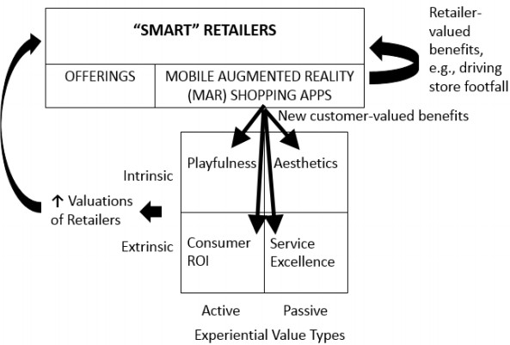

Figure 2.6 Conceptual model of the role of MAR apps in smart retailing

Conclusions from the study indicate that user satisfaction is comparatively elevated, and their usage offers methodical practical advances alongside benefits to retailers. Despite a few shortcomings, their application is certainly correlated with various marketing moments. MAR apps are transforming customer behavior and are linked with progressively high customer evaluations of merchants presenting them. Consequences of supplementary successful use to empower smart marketing situations are debated.

Document [20] examines the present situation of AR products for various devices. It highlights the regions within education that have been positively impacted and provide a shortlist of outstanding apps and the major technical components of augmented reality applications. Configuration with educational theory will encourage the usage of the new technology. Numerous obstacles to the full incorporation of AR into education are reviewed. It is concluded that AR has proved to be successful among various topics.

AR has undertaken significant advancement in previous years. Numerous unique methods and technologies were established, but the vital innovation arrived with the propagation of smart handheld devices. This aided the mass spread of AR applications. Though portable devices have restricted technology abilities, which restricts the techniques compatible. In this article, an AR application is offered which utilizes cloud computing to facilitate the employment of further complicated computational techniques such as neural networks. The aim [22] is to develop a reasonably priced AR application.

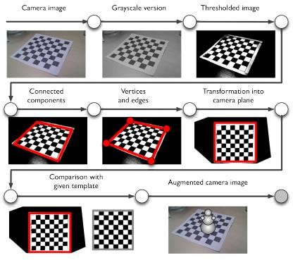

Figure 2.7 Representation of artificial markers in an AR application

The prototype of ShelfTorchlight [23] is presented with the following key factors:

* ShelfTorchlight operates on a handheld device unit to improve the search for the required item on a shelf.
* It accepts the projection of supplementary data about the product in a region.
* One major advantage of the presented prototype is that it is lightweight and mobile
* It does not need a huge amount of auxiliary infrastructure and all the needed information is retrieved from the web.
* technical drawbacks (e.g. low brightness of the projection) of mobile camera projector units exist

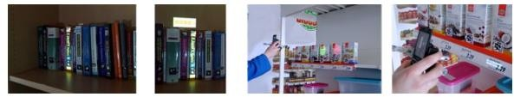

Figure 2.8 ShelfTorchlight in use

Piece [24] examines the element of disagreements about an experience- adjusted market and utilization in retailing. It is indicated how stores as well as customers connect with in-store experiences. By comparison, the portrayal offered by customers uncovers that the in-store encounters to a huge amount are represented by conventional principles such as the conduct of the employees, a reasonable range of products, and a design that accelerates the store visit.

Key Points:

* The merchants all indicated to the fact that attention on in-store ‘experiences’ has increased.
* The merchants furthermore considered an appealing shop natural atmosphere as a crucial characteristic to prosper as an experience- adapted business.
* Findings also indicate that merchants are progressively more concentrated on originality and innovative combinations of products.

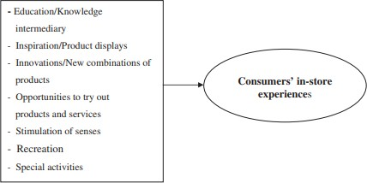

Figure 2.9 Central aspects of experimental consumption from the retailers' point of view

In article [25], a structure is introduced that transforms handsets into portable radars. The proposed procedure induces coordinate method to track phone movement. It captures the gyration and the quantity of slanting as supplementary input constraints. This also allow applications like article range and communication with bigger display. With the coordination, individual point in the display can be connected to functions. A single image point can even be correlated with various data facets by bringing various sequence and sloping into account.

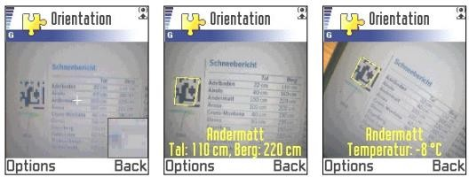

Figure 2.10 Camera rotation and orientation record

An interactive Augmented Reality design and control engine is portrayed in [26]. Computer vision techniques are developed for building marker-less object recognition. Although fiducials presently represent the most viable solution, constriction as other assembly parts make the employment of common computer vision methods necessary. CV techniques are examined to ultimately replace markers.

Paper [27] discussed the term context and the diverse behaviors that can be employed by context-aware applications have been discussed. Introduced design encourages the construction of these context-aware functions. The highlights and concepts in the toolkit that get the job of constructing applications simpler have been underlined.

Document [28] has portrayed a model AR structure that utilizes CV to identify an item and convey it. To streamline the task, fiducial targets were positioned on the pieces to be identified. The structure calculates the pose of the objects and exhibits visuals overlays on the display. This document illustrates the design of the structure and summarizes the computer vision practices used.

* 1. **INFERENCE FROM SURVERY**

For many years now, markers-based applications are the only successful real-time applications. Though, markers are a partial solution because they still necessitate engineering the situation, work on a limited range, and end- users often do not prefer them.

Computer Vision has fantastic capacity for AR applications. Since it can depend on graphic attributes that are innately current to register the camera, it does not require planning the environment and is not restricted to a small amount, like magnetic, mechanical, or ultrasonic sensors are.

Robustness of camera registration is not the only characteristic of AR where object recognition techniques can contribute. Managing occlusions between the real objects and the virtual ones can also be accomplished.

There has been a major resurgence in the application of AR in retail and commerce as it improves user experience. Some previous works have targeted clothing, library systems, product assembly, and construction lines. The majority of these have been executed on mobile applications to improve feasibility and handiness and reduce hardware costs. Augmented Reality has benefited user interaction and satisfaction with the targeted product.

**CHAPTER 3**

**METHODOLOGY**

* 1. **EXISTING AND PROPOSED SYSTEM**

The existing system is the classic system of in-store shopping. As demonstrated in Fig. 3.1, the user picks up the product, for any kind of queries, the user would either try reaching out to a salesperson in the store or they will look up to a search engine.

If the user needs to check if the product meets a certain dietary requirement, they will have to analyse the ingredients list on the product packaging. To search for alternative products, the customer would have to manually search along aisles and shelves. For customers that are dealing with foreign products, they would try to use translation apps which might not be perfectly accurate. At the end of these, the chances are greater that the user might not choose to buy the product. This is disadvantageous not only to the customer in terms of the amount of time spent in making their decisions but also to the store and the brand.

Figure 3.1 An overview of the existing shopping system

The proposed system offers a more streamlined approach for the same situation. It first aims to remove the salesperson from the user’s shopping experience to the maximum intent. There are multiple reasons why this is advantageous – the salesperson might not be as familiarized with the product as would be expected, in pandemic related situations or with reticent customers, the customer might not feel comfortable interacting with them. This allows the user to achieve maximum information from the own device itself. This also ensures that the information that is provided to the customer is always consistent. The proposed design as shown in Fig. 3.2, then aims to provide maximum information to the customer that would be beneficial in making the decision, this would include dietary details, prices, discounts, alternatives, ratings in the form of 3D models that would work as extremely effective visual aid.

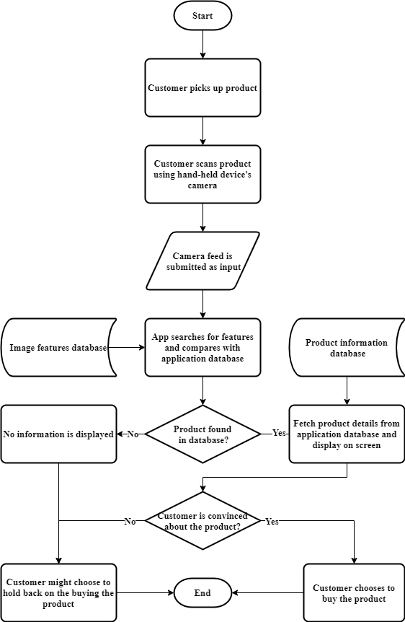

Figure 3.2 An overview of the proposed shopping system

* 1. **SYSTEM ARCHITECTURE**

There are 2 actors involved in this design as represented in Fig. 3.3 – the user and the developer. The user interacts with the application on their hand-held device, the scanner, the image recognition module and the information overlay. The developer interacts with the database, the image recognition module, the information overlay, and the application.

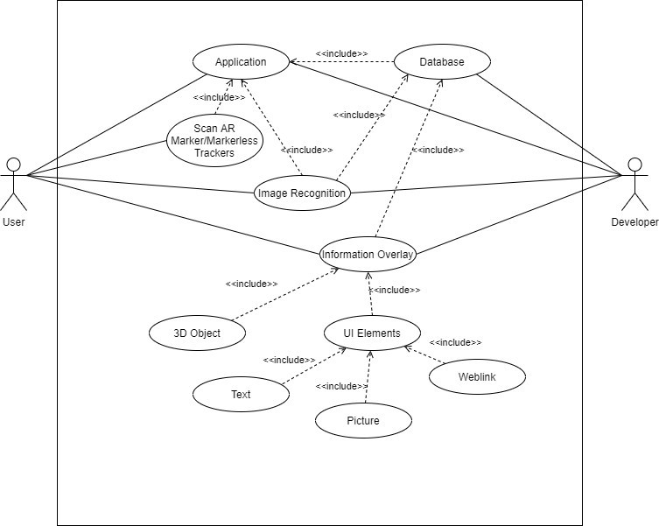

Figure 3.3 The UML use-case diagram of the system architecture

The design can also be defined in a sequence of activities as represented in Fig. 3.4 starting from the application scanner to the application screen, wherein the activity will move between the feature extraction, the feature and UI database and the information overlay.

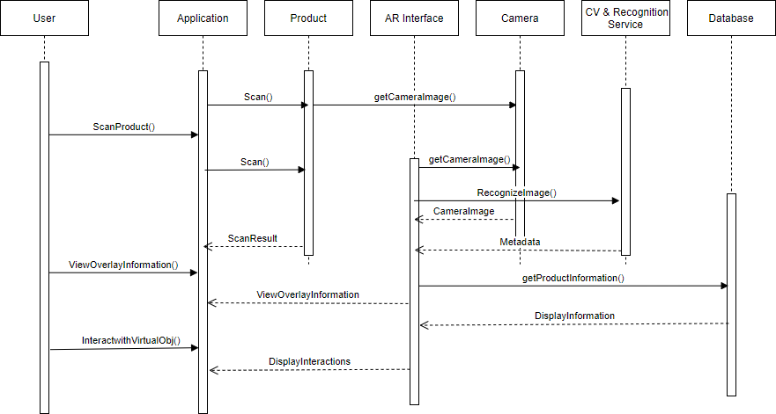

Figure 3.4 The UML sequence diagram of the system architecture.

There are 2 classes of object in this design Fig. 3.5. The user of the of the application and the different products that the user interacts with. These user object holds attributes for the user information such as login and profile details.

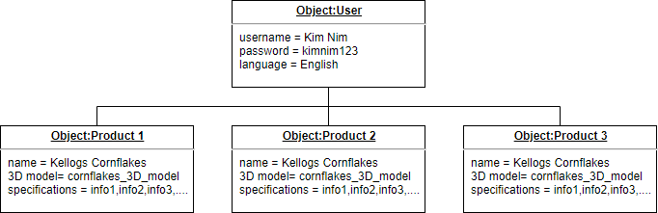

Figure 3.5 The UML object diagram of the system architecture.

* 1. **HARDWARE AND SOFTWARE REQUIREMENTS**

The foundation of this application is built upon the Image Tracking API capability provided by the Vuforia Engine SDK, which allows to track multi image targets. The system is built upon the Unity Engine and deployed on Android Studio. The 3D models presented have been modelled and rendered on Blender and Unity. The User Interface elements have been embedded onto the objects using the Unity Game Engine as well.

As is displayed in Fig. 3.6, the project can be accessed and run on Android devices running that are Augmented Reality (AR) compatible. AR compatible devices must be able to run Google’s ARCore. This application enables smartphones and tablets to operate AR based applications. In order to verify if a particular device is compatible, one can check Google Developers AR supported devices document. This document has a list of all devices that can successfully enable AR applications to work.

Additionally, the document also specifies the Android OS versions required in order to run the application. In other words, the project requires the system to be running on an OS version of Android 8.0 and above, let alone a few exceptions. The device also requires a minimum of 100MB storage space. Preferably, if the device is compatible with ARCore, it is advised that it is updated to its latest OS version in order to smoothly run the project. It is required by the user to provide permissions for the camera to be accessed in order to run the AR Application.

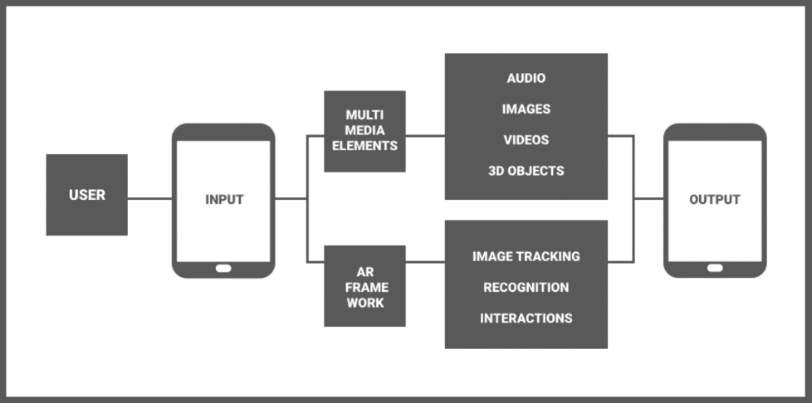

Figure 3.6 Diagrammatic representation of the hardware and software requirements for the architecture

* 1. **FEATURE TRACKING WITH AUGEMENTED REALITY**

The Vuforia Engine is a widely used software development kit for AR development which supports multiple devices. It provides advanced Computer Vision functionalities that allow the users to interact with an object and its environment. Majority of its computer vision functionalities are based upon object recognition with feature tracking. In computer vision, features are the differentiating details about an image which make up its content, such as edges, corners, blobs, ridges etc. These features summed up together allow to track images which are static and unique. This works well in the case of product packaging, which is consistent across all products. Thus, feature tracking is more accurate as opposed to image tracking in the case of constant images as it does not require a large data set to train upon.

The Vuforia Engine employs a similar approach by using Image Targets. Image Targets can be defined in the Vuforia Target Library. These prominent features will be recorded as visible in Fig. 3.7 and can later be used to track objects in a scene. The natural components of the registered objects that have been registered as image targets is compared against the scene elements, upon the discovery of which 3D models and other content and UI elements are augmented upon it. The Vuforia Engine’s Image Tracking API supports RGB or grayscale images. To avoid loss in accuracy due to occlusions and lighting, the images used in the data set are of higher contrast, which generates more pronounced features. Modifying the device spec and settings also improves the accuracy of the system.

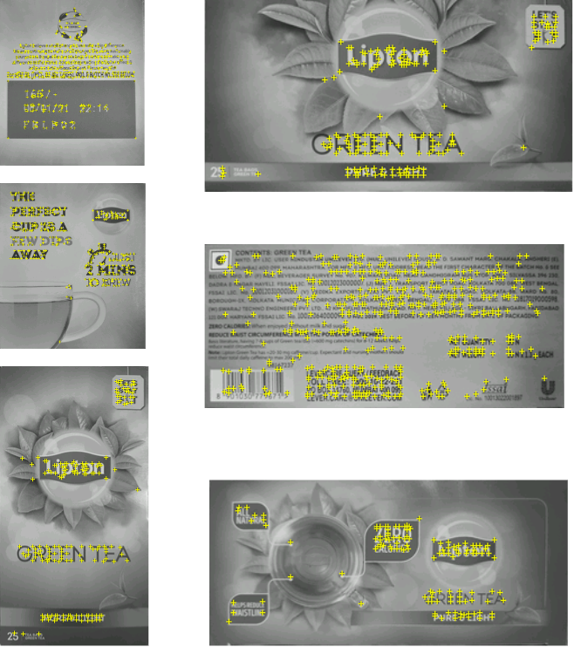

Figure 3.7 Output of the feature recognition performed on the different faces of the product packaging image

* 1. **3D MODEL DESIGN AND UI ELEMENTS**

The project incorporates 3D models and additional product features to enhance the experience for the user by giving them a more visually pleasing manner of the information pertaining to the product they scan. The 3D models have been designed in such a way that they convey the realism of the product in a daily setting. Fig. 3.8. Shows the rendered image of the 3D model of a teacup. These were created using Blender and rendered with the software’s “Cycles” render. Every 3D model was created with real images as reference and either sculpted or modelled depending on their design being regular or irregular in nature.

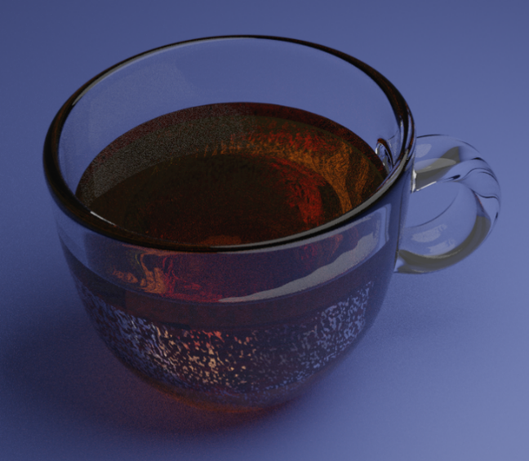

Figure 3.8 Rendered image of the 3D model of a teacup

Upon researching product features that customers are most interested in knowing we have included information in a concise and easy to read fashion. The product features are displayed using User Interface elements. These can be designed in any manner possible and their goal is to convey information about the product that cannot be present on the packaging. The UI elements present here can also be made to be interactive to improve engagement. For the application, the UI was created using images, 3D text and TextMeshPro. The images added to improve the UI were designed using Figma and serve the purpose for potential interactions or aesthetics.

* 1. **MAINTAINING DATABASES AND SETTING UP CLOUD**

Deploying the application in the real world would require the application to be able to dynamic, in terms of the products and its packaging. The Vuforia Engine SDK provides cloud services via the Vuforia Web Services which allows to register and store image targets on the cloud. The respective metadata for the products can accordingly be register and extracted when the application is deployed.

The product databases are maintained using a labelling system that manages the Parent Company, the brand and the label to build proper referencing between the products. It follows the following convention. This allows to tag the different product under different categories and brands and labels. Maintaining a cloud database is vital for this design since product packaging is extremely dynamic and will constantly be changing. Information that is displayed from the UI elements will be needed to be maintained on databases for more robust modifications.

**CHAPTER 4**

**OBSERVATION AND RESULTS**

As is visible in Fig. 3.9, important information about the product is overlay as AR elements. Details on the product, dietary information, advertisements, pricing, discounts, alternative product information and features of the product are visible. Information that is not generally visible on the packaging and is not as directed when searched on a web service can be viewed. When viewing a product through the application, a comparative study is provided with the top contenders in the market. The product ratings are also provided which intend to represent the product’s popularity and trustworthiness compared to the peers in the product category.

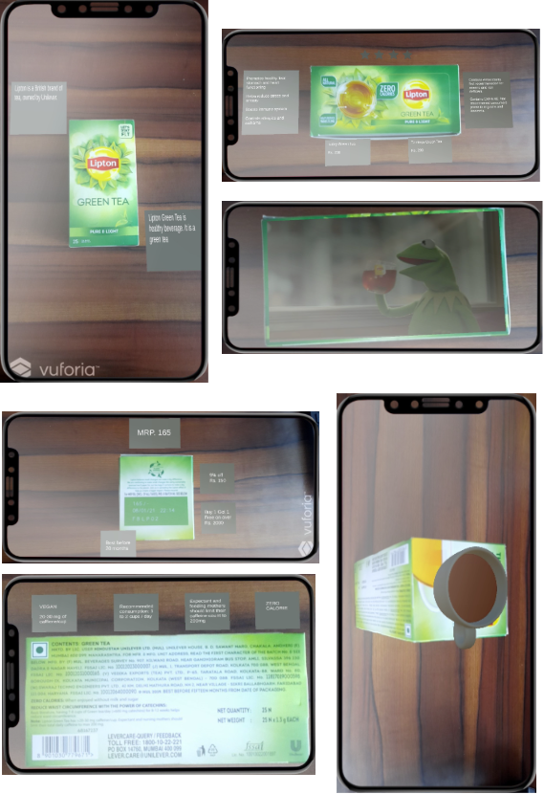

Figure 4.1 Output images of the running application.

**CHAPTER 5**

**CONCLUSION**

As can be concluded from the observed results, by utilizing Augmented Reality and Image Processing capabilities, the design can improve and digitizing the in-store shopping experience. The results conclude that such a design can benefit users who have any difficulty in reading product information that would help them make a smart and informed decision while purchasing. Users will have an easier to read overlay of information on the product that not only specifies important facts that could affect them upon product usage but also highlights product details that are difficult to read.

Potentially, we can add virtual interactions and features that would allow the user to observe more information regarding the product and interact with it in a holistic manner. The 3d models can be animated to enhance the realism aspect of it and depending on the product, can have audio-visual interactions. We can increase the scope of the project by using marker less trackers and frameworks such as AR Core and AR Foundation. Alternatively, the project could be developed and deployed using a more powerful game engine such as Unreal Engine. The current scope of the project is restricted to the Android OS; with better resources, this same project can be deployed for iOS as well with ARKit.

**REFERENCES**

1. Dave Chaffey, The reasons why consumers shop online instead of in stores, Smart Insights, Oct. 2017. Accessed on: Jan 12, 2021. [Online]. https : / / www . smartinsights . com / ecommerce / ecommerce-strategy / the-reasons-why-consumers-shop-online-instead-of-in-stores/
2. Cao, Sheng Wang, Qian. (2017). Application and Prospect of AR Technology in E-commerce. 10.2991/emcs-17.2017.262
3. Boardman, Rosy Henninger, Claudia Zhu, Ailing. (2020). Augmented Reality and Virtual Reality: New Drivers for Fashion Retail?. 10.1007/978-3-030-15483-7_9.
4. Pachoulakis, Ioannis Kapetanakis, Kostas. (2012). Augmented Reality Platforms for Virtual Fitting Rooms. The International journal of Multimedia Its Applications. 4. 10.5121/ijma.2012.4404
5. Chen, David Tsai, Sam Hsu, Cheng-Hsin Singh, Jatinder Girod, Bernd. (2011). Mobile augmented reality for books on a shelf. Multimedia and Expo (ICME), 2011 IEEE International Conference on. 1-6. 10.1109/ICME.2011.6012171.
6. You, Yuhui and Kelvin Cheng. “RARE Shop: Real Augmented Retail Bookshop Experience using Projection Mapping.”. Proceedings of the 2019 ACM International Conference on Interactive Surfaces and Spaces.(2019): n. pag.
7. Ozturkcan, S. (2020) ‘Service innovation: Using augmented reality in the IKEA Place app’, Journal of Information Technology Teaching Cases. doi: 10.1177/2043886920947110.
8. Heinzel, Alex Azhar, Salman Nadeem, Abid. (2017). Uses of Augmented Reality Technology during Construction Phase.
9. Henrysson, Anders. “Bringing Augmented Reality to Mobile Phones.” (2007).
10. Deeba K., Amutha B. (2019) Identification of Vegetable Plant Species Using Support Vector Machine. In: Kumar A., Mozar S. (eds) ICCCE 2018. ICCCE 2018. Lecture Notes in Electrical Engineering, vol 500. Springer, Singapore.
11. K. Deeba, B. Amutha, ResNet - deep neural network architecture for leaf disease classification, Microprocessors and Microsystems, 2020, 103364, ISSN 0141-9331.
12. Mohamed, Tarek. (2020). The Impact of Using Virtual-Augmented Reality on Some Design Careers (Product, Multimedia, Graphic). 54- 59. 10.1145/3404716.3404736.
13. Fuchs, Klaus Grundmann, Tobias Fleisch, Elgar. (2019). Towards Identification of Packaged Products via Computer Vision: Convolutional Neural Networks for Object Detection and Image Classification in Retail Environments. 1-8. 10.1145/3365871.3365899
14. Amutha, B., and M. Ponnavaikko. "Predator-The Blind Vision-Mobile Assistant as a Navigational Aid to Identify Landmarks." International Journal of Recent Trends in Engineering 2.3 (2009).
15. Välkkynen, Pasi et al. “Mobile Augmented Reality for Retail Environments.” (2011)
16. X. Qiao, P. Ren, S. Dustdar, L. Liu, H. Ma and J. Chen, "Web AR: A Promising Future for Mobile Augmented Reality—State of the Art, Challenges, and Insights," in Proceedings of the IEEE, vol. 107, no. 4, pp. 651-666, April 2019, doi: 10.1109/JPROC.2019.2895105.
17. Kelvin Cheng, Mitsuru Nakazawa, Soh Masuko. MR-Shoppingu: Physical Interaction with Augmented Retail Products Using Continuous Context Awareness. 16th International Conference on Entertainment Computing (ICEC), Sep 2017, Tsukuba City, Japan. pp.452-455, ⟨10.1007/978-3-319-66715- 7_61⟩. ⟨hal-01771288⟩
18. Santos, J., and Sharon Maria S. Esposo-Betan. “Advantages and Challenges of Using Augmented Reality for Library Orientations in an Academic/Research Library Setting.” (2018).
19. Dacko, Scott G., 2017. "Enabling smart retail settings via mobile augmented reality shopping apps," Technological Forecasting and Social Change, Elsevier, vol. 124(C), pages 243-256.
20. Bitter, Gary. (2014). The Pedagogical Potential of Augmented Reality Apps. International Journal of Engineering Science Invention. 3. 13-17.
21. A.Y.C. Nee, S.K. Ong, Virtual and Augmented Reality Applications in Manufacturing, IFAC Proceedings Volumes, Volume 46, Issue 9, 2013, Pages 15-26, ISSN 1474-6670, ISBN 9783902823359, <https://doi.org/10.3182/20130619-3-RU-3018.00637>.
22. Procházka, David & Stencl, Michael & Popelka, Ondřej & Stastny, Jiri. (2011). Mobile Augmented Reality Applications. Mendel.
23. Löchtefeld, Markus & Gehring, Sven & Schöning, Johannes & Krüger, Antonio. (2010). ShelfTorchlight: Augmenting a Shelf using a Camera Projector Unit.
24. Bäckström, Kristina & Johansson, Ulf. (2006). Creating and consuming experiences in retail store environments: Comparing retailer and consumer perspectives. Journal of Retailing and Consumer Services. 13. 417-430. 10.1016/j.jretconser.2006.02.005.
25. Rohs, M. “Real-World Interaction with Camera Phones.” UCS (2004)
26. Molineros J., Sharma R. (2004) Vision-based Augmented Reality for Guiding Assembly. In: Ong S.K., Nee A.Y.C. (eds) Virtual and Augmented Reality Applications in Manufacturing. Springer, London. <https://doi.org/10.1007/978-1-4471-3873-0_15>.
27. Dey, A.K. (2001). Understanding and Using Context. Personal and Ubiquitous Computing, 5, 4-7.
28. William A. Hoff, Khoi Nguyen, and Torsten Lyon "Computer-vision-based registration techniques for augmented reality", Proc. SPIE 2904, Intelligent Robots and Computer Vision XV: Algorithms, Techniques, Active Vision, and Materials Handling, (29 October 1996); <https://doi.org/10.1117/12.256311>
29. Jeya, R., Rajesbabu, C., Singh, J., Singh, A. (2020). Iot based stolen vehicle monitoring system. International Journal of Engineering Technology.29(6), pp. 472–48

**APPENDIX 1**

**MARKET STUDY**

Customers will use this application when they need to assess and make an educated decision about purchasing a consumer good at an offline store. The application will be used after the customer mentally assesses the item on the stand, in order to gather valuable information.

Areas of Consumer Products:

1. Durable (Electronic goods such as a Video Game CD)
2. Non-Durable (Grocery items such as Lipton Green Tea)

Textual Information Displayed:

* Brand
* Brand Details
* Rating
* Price
* Product Details
* Manufacture and Expiry Date (if applicable)
* Health Risks/Benefits
* Points of Comparison (Cost and details compared with alternatives/competition in the market)
* Discounts
* Offers

The target audience chosen for this research mainly focuses on the working class, travelers / tourists, senior citizens, reticent customers and customers that require reading glasses / eye ware where the potentially age ranges below 18, young adults and visually impaired range. Since the application requires a handheld device to be deployed upon, the younger demographic is expected to be quicker at adapting to the application and it’s features thus the application aims to be simplified to the maximum level to target the older demographic.

Based on the category of the item, the following information will most likely be viewed by the Customer (not considering Discounts and Offers:

* Groceries – Expiry Date, Price, Points of Comparison, Health Risks/Benefits, Rating
* Electronics – Price, Rating, Points of Comparison, Brands
* Personal Care – Product Details, Health Risks/Benefits, Price, Brand, Points of Comparison, Rating

The market study against the application features brings us to the conclusion that the application will help improve engagement of customers with brands and consumer goods, increased transparency, ease in viewing and reviewing items for purchasing, elimination of doubts and concerns of the end users and an enriched shopping experience.

Areas of Expansion based on Audience Preference and Feedback:

* User Interface
* Application Functionalities
* Textual Information Displayed on the product
* Adding new information
* Eliminating unnecessary information

Results of a survey that we conducted to better understand the market and its requirements:

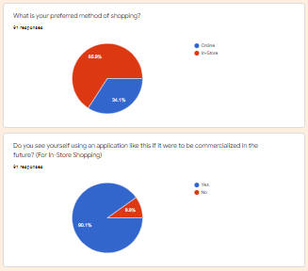 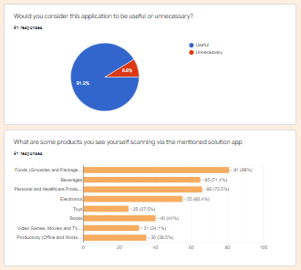

Fig A 1.1 Survey Results

**APPENDIX 2**

**CODE**

TrackableEventHandler.cs

using UnityEngine;

using Vuforia;

using UnityEngine.Events;

public class TrackableEventHandler : MonoBehaviour, ITrackableEventHandler

{

#region PROTECTED_MEMBER_VARIABLES

public UnityEvent onTrack;

public UnityEvent onLost;

protected TrackableBehaviour mTrackableBehaviour;

protected TrackableBehaviour.Status m_PreviousStatus;

protected TrackableBehaviour.Status m_NewStatus;

#endregion

#region UNITY_MONOBEHAVIOUR_METHODS

protected virtual void Start()

{

mTrackableBehaviour = GetComponent<TrackableBehaviour>();

if (mTrackableBehaviour)

mTrackableBehaviour.RegisterTrackableEventHandler(this);

}

protected virtual void OnDestroy()

{

if (mTrackableBehaviour)

mTrackableBehaviour.UnregisterTrackableEventHandler(this);

}

#endregion

#region PUBLIC_METHODS

public void OnTrackableStateChanged(

TrackableBehaviour.Status previousStatus,

TrackableBehaviour.Status newStatus)

{

m_PreviousStatus = previousStatus;

m_NewStatus = newStatus;

Debug.Log("Trackable " + mTrackableBehaviour.TrackableName +

" " + mTrackableBehaviour.CurrentStatus +

" -- " + mTrackableBehaviour.CurrentStatusInfo);

if (newStatus == TrackableBehaviour.Status.DETECTED ||

newStatus == TrackableBehaviour.Status.TRACKED ||

newStatus == TrackableBehaviour.Status.EXTENDED_TRACKED)

{

onTrack.Invoke();

OnTrackingFound();

}

else if (previousStatus == TrackableBehaviour.Status.TRACKED &&

newStatus == TrackableBehaviour.Status.NO_POSE)

{

onLost.Invoke();

OnTrackingLost();

}

else

{

OnTrackingLost();

}

}

#endregion

#region PROTECTED_METHODS

protected virtual void OnTrackingFound()

{

if (mTrackableBehaviour)

{

var rendererComponents = mTrackableBehaviour.GetComponentsInChildren<Renderer>(true);

var colliderComponents = mTrackableBehaviour.GetComponentsInChildren<Collider>(true);

var canvasComponents = mTrackableBehaviour.GetComponentsInChildren<Canvas>(true);

// Enable rendering

foreach (var component in rendererComponents)

component.enabled = true;

// Enable colliders

foreach (var component in colliderComponents)

component.enabled = true;

// Enable canvas

foreach (var component in canvasComponents)

component.enabled = true;

}

}

protected virtual void OnTrackingLost()

{

if (mTrackableBehaviour)

{

var rendererComponents = mTrackableBehaviour.GetComponentsInChildren<Renderer>(true);

var colliderComponents = mTrackableBehaviour.GetComponentsInChildren<Collider>(true);

var canvasComponents = mTrackableBehaviour.GetComponentsInChildren<Canvas>(true);

// Disable rendering

foreach (var component in rendererComponents)

component.enabled = false;

// Disable colliders

foreach (var component in colliderComponents)

component.enabled = false;

// Disable canvas

foreach (var component in canvasComponents)

component.enabled = false;

}

}

#endregion // PROTECTED_METHODS

}

ProductScanDatabase.xml

<?xml version="1.0" encoding="UTF-8"?>

<QCARConfig xmlns:xsi="http://www.w3.org/2001/XMLSchema-instance" xsi:noNamespaceSchemaLocation="qcar_config.xsd">

<Tracking>

<ImageTarget name="010104_2" size="0.134000 0.168438" />

<ImageTarget name="010104_1" size="0.134000 0.168572" />

<ImageTarget name="010103_6" size="7.000000 7.980000" />

<ImageTarget name="010103_5" size="7.000000 8.019667" />

<ImageTarget name="010103_4" size="15.000000 7.132500" />

<ImageTarget name="010103_3" size="15.000000 7.766250" />

<ImageTarget name="010103_2" size="15.000000 6.765000" />

<ImageTarget name="010103_1" size="8.000000 15.044663" />

<ImageTarget name="010102_2" size="13.000000 16.538988" />

<ImageTarget name="010102_1" size="13.000000 18.376661" />

<ImageTarget name="010101_6" size="0.154000 0.070532" />

<ImageTarget name="010101_5" size="0.072000 0.082440" />

<ImageTarget name="010101_4" size="0.072000 0.081960" />

<ImageTarget name="010101_3" size="0.154000 0.071263" />

<ImageTarget name="010101_2" size="0.154000 0.080812" />

<ImageTarget name="010101_1" size="0.081000 0.152471" />

</Tracking>

</QCARConfig>

RunTimeOperSourceInitializer.cs

using System;

using UnityEngine;

using UnityEngine.EventSystems;

#if PLATFORM_ANDROID

using UnityEngine.Android;

#endif

namespace Vuforia.UnityCompiled

{

public class RuntimeOpenSourceInitializer

{

static IUnityCompiledFacade sFacade;

[RuntimeInitializeOnLoadMethod(RuntimeInitializeLoadType.BeforeSceneLoad)]

static void OnRuntimeMethodLoad()

{

InitializeFacade();

}

static void InitializeFacade()

{

if (sFacade != null) return;

sFacade = new OpenSourceUnityCompiledFacade();

UnityCompiledFacade.Instance = sFacade;

}

class OpenSourceUnityCompiledFacade : IUnityCompiledFacade

{

readonly IUnityRenderPipeline mUnityRenderPipeline = new UnityRenderPipeline();

readonly IUnityAndroidPermissions mUnityAndroidPermissions = new UnityAndroidPermissions();

public IUnityRenderPipeline UnityRenderPipeline

{

get { return mUnityRenderPipeline; }

}

public IUnityAndroidPermissions UnityAndroidPermissions

{

get { return mUnityAndroidPermissions; }

}

public bool IsUnityUICurrentlySelected()

{

return !(EventSystem.current == null || EventSystem.current.currentSelectedGameObject == null);

}

}

class UnityRenderPipeline : IUnityRenderPipeline

{

public event Action<Camera[]> BeginFrameRendering;

public event Action<Camera> BeginCameraRendering;

public UnityRenderPipeline()

{

#if UNITY_2018

UnityEngine.Experimental.Rendering.RenderPipeline.beginFrameRendering += OnBeginFrameRendering;

UnityEngine.Experimental.Rendering.RenderPipeline.beginCameraRendering += OnBeginCameraRendering;

#else

UnityEngine.Rendering.RenderPipelineManager.beginFrameRendering += OnBeginFrameRendering;

UnityEngine.Rendering.RenderPipelineManager.beginCameraRendering += OnBeginCameraRendering;

#endif

}

#if UNITY_2018

void OnBeginCameraRendering(Camera camera)

#else

void OnBeginCameraRendering(UnityEngine.Rendering.ScriptableRenderContext context, Camera camera)

#endif

{

if (BeginCameraRendering != null)

BeginCameraRendering(camera);

}

#if UNITY_2018

void OnBeginFrameRendering(Camera[] cameras)

#else

void OnBeginFrameRendering(UnityEngine.Rendering.ScriptableRenderContext context, Camera[] cameras)

#endif

{

if (BeginFrameRendering != null)

BeginFrameRendering(cameras);

}

}

class UnityAndroidPermissions : IUnityAndroidPermissions

{

public bool HasRequiredPermissions()

{

#if PLATFORM_ANDROID

return Permission.HasUserAuthorizedPermission(Permission.Camera);

#else

return true;

#endif

}

public void AskForPermissions()

{

#if PLATFORM_ANDROID

Permission.RequestUserPermission(Permission.Camera);

#endif

}

}

}

}

AndroidManifest.xml

*<?*xml version="1.0" encoding="utf-8"*?>*<manifest xmlns:android="http://schemas.android.com/apk/res/android" package="com.ARCV.ProductScan" xmlns:tools="http://schemas.android.com/tools" android:installLocation="preferExternal">  
 <supports-screens android:smallScreens="true" android:normalScreens="true" android:largeScreens="true" android:xlargeScreens="true" android:anyDensity="true" />  
 <application android:theme="@style/UnityThemeSelector" android:icon="@mipmap/app_icon" android:label="@string/app_name">  
 <activity android:label="@string/app_name" android:screenOrientation="fullSensor" android:launchMode="singleTask" android:configChanges="mcc|mnc|locale|touchscreen|keyboard|keyboardHidden|navigation|orientation|screenLayout|uiMode|screenSize|smallestScreenSize|fontScale|layoutDirection|density" android:hardwareAccelerated="false" android:name="com.ARCV.ProductScan.UnityPlayerActivity">  
 <intent-filter>  
 <action android:name="android.intent.action.MAIN" />  
 <category android:name="android.intent.category.LAUNCHER" />  
 </intent-filter>  
 <meta-data android:name="unityplayer.UnityActivity" android:value="true" />  
 <meta-data android:name="android.notch_support" android:value="true" />  
 </activity>  
 <meta-data android:name="unity.build-id" android:value="9832fcbe-8f7f-44ca-b219-f823e3377cd5" />  
 <meta-data android:name="unity.splash-mode" android:value="0" />  
 <meta-data android:name="unity.splash-enable" android:value="True" />  
 <meta-data android:name="notch.config" android:value="portrait|landscape" />  
 </application>  
 <uses-feature android:glEsVersion="0x00020000" />  
 <uses-permission android:name="android.permission.INTERNET" />  
 <uses-permission android:name="android.permission.CAMERA" />  
 <uses-feature android:name="android.hardware.camera" android:required="false" />  
 <uses-feature android:name="android.hardware.camera.autofocus" android:required="false" />  
 <uses-feature android:name="android.hardware.camera.front" android:required="false" />  
 <uses-feature android:name="android.hardware.touchscreen" android:required="false" />  
 <uses-feature android:name="android.hardware.touchscreen.multitouch" android:required="false" />  
 <uses-feature android:name="android.hardware.touchscreen.multitouch.distinct" android:required="false" />  
</manifest>

UnityPlayerActivity.java

package com.ARCV.ProductScan;  
  
import com.unity3d.player.*;  
import android.app.Activity;  
import android.content.Intent;  
import android.content.res.Configuration;  
import android.graphics.PixelFormat;  
import android.os.Bundle;  
import android.view.KeyEvent;  
import android.view.MotionEvent;  
import android.view.View;  
import android.view.Window;  
import android.view.WindowManager;  
  
public class UnityPlayerActivity extends Activity  
{  
 protected UnityPlayer mUnityPlayer;   
  
 @Override protected void onCreate(Bundle savedInstanceState)  
 {  
 requestWindowFeature(Window.FEATURE_NO_TITLE);  
 super.onCreate(savedInstanceState);  
  
 mUnityPlayer = new UnityPlayer(this);  
 setContentView(mUnityPlayer);  
 mUnityPlayer.requestFocus();  
 }  
  
 @Override protected void onNewIntent(Intent intent)  
 {  
 setIntent(intent);  
 }  
  
 @Override protected void onDestroy ()  
 {  
 mUnityPlayer.destroy();  
 super.onDestroy();  
 }  
  
 Override protected void onPause()  
 {  
 super.onPause();  
 mUnityPlayer.pause();  
 }  
  
 Override protected void onResume()  
 {  
 super.onResume();  
 mUnityPlayer.resume();  
 }  
  
 @Override protected void onStart()  
 {  
 super.onStart();  
 mUnityPlayer.start();  
 }  
  
 @Override protected void onStop()  
 {  
 super.onStop();  
 mUnityPlayer.stop();  
 }  
  
 @Override public void onLowMemory()  
 {  
 super.onLowMemory();  
 mUnityPlayer.lowMemory();  
 }  
  
 @Override public void onTrimMemory(int level)  
 {  
 super.onTrimMemory(level);  
 if (level == TRIM_MEMORY_RUNNING_CRITICAL)  
 {  
 mUnityPlayer.lowMemory();  
 }  
 }  
  
 @Override public void onConfigurationChanged(Configuration newConfig)  
 {  
 super.onConfigurationChanged(newConfig);  
 mUnityPlayer.configurationChanged(newConfig);  
 }  
  
 @Override public void onWindowFocusChanged(boolean hasFocus)  
 {  
 super.onWindowFocusChanged(hasFocus);  
 mUnityPlayer.windowFocusChanged(hasFocus);  
 }  
  
 @Override public boolean dispatchKeyEvent(KeyEvent event)  
 {  
 if (event.getAction() == KeyEvent.ACTION_MULTIPLE)  
 return mUnityPlayer.injectEvent(event);  
 return super.dispatchKeyEvent(event);  
 }  
  
 @Override public boolean onKeyUp(int keyCode, KeyEvent event) { return mUnityPlayer.injectEvent(event); }  
 @Override public boolean onKeyDown(int keyCode, KeyEvent event) { return mUnityPlayer.injectEvent(event); }  
 @Override public boolean onTouchEvent(MotionEvent event) { return mUnityPlayer.injectEvent(event); }  
 public boolean onGenericMotionEvent(MotionEvent event) { return mUnityPlayer.injectEvent(event); }  
}

BuildConfig.java

package com.ARCV.ProductScan;  
  
public final class BuildConfig {  
 public static final boolean DEBUG = Boolean.parseBoolean("true");  
 public static final String APPLICATION_ID = "com.ARCV.ProductScan";  
 public static final String BUILD_TYPE = "debug";  
 public static final String FLAVOR = "";  
 public static final int VERSION_CODE = 1;  
 public static final String VERSION_NAME = "0.1";  
}

**PLAGIARISM REPORT**

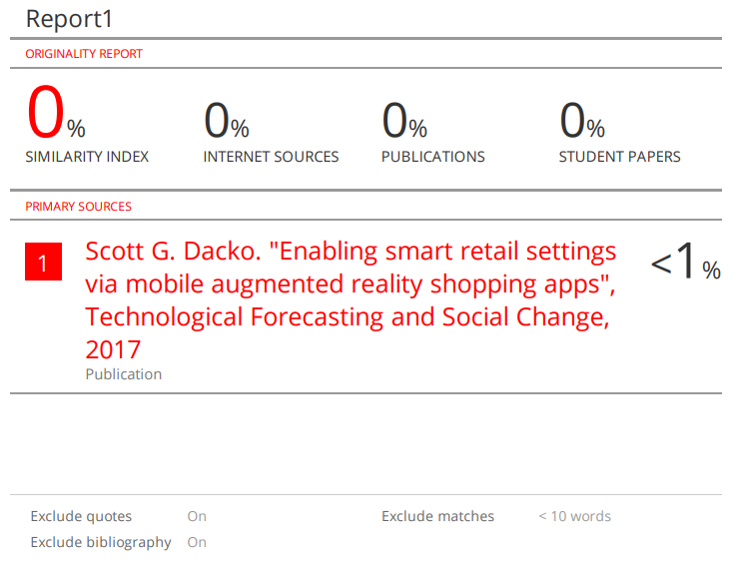



**PAPER PUBLICATION PROOF**

